Meta Description:
Want to build a powerful brand in the UAE? Discover 10 proven branding strategies to enhance brand visibility, boost customer engagement, and stay ahead of the competition.

Top 10 Proven Branding Tips to Transform Your Business in the UAE
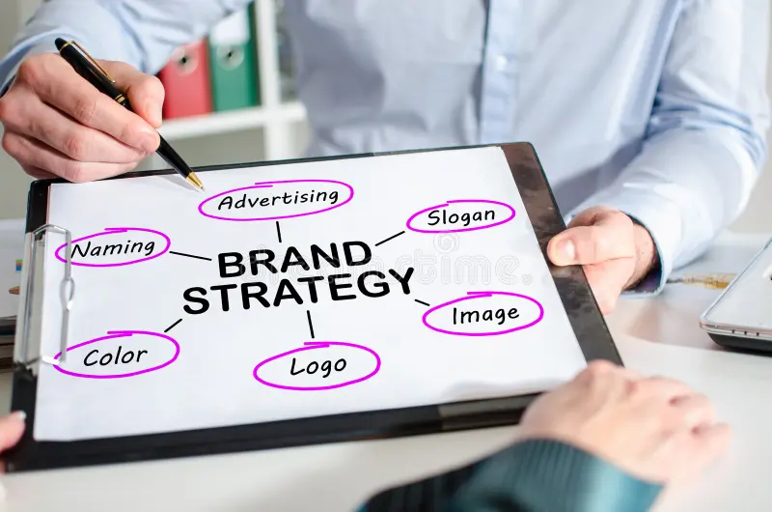
A positive or negative perception of a brand most of the time decides customers' loyalty level. A brand that has a positive perception among its potential customers always has a higher conversion rate in comparison to a brand that has a negative perception.
If we talk about brand perception, it heavily depends on its branding strategies. Branding in the current business context is not limited to the business logo and motto. It is an excellent way through which a business can highlight its persona and potential in the market.
As for the UAE market, business needs a powerful position, which can be achieved through effective Brand Strategy Services Dubai. Apart from improving position, brand strategy services also help to enhance brand engagement, improve marketing effectiveness, and build customer loyalty.
Below are the ten branding tips that can be used to change your business in the UAE, when you get brand strategy services from a reliable partner in the UAE.

Harness the Power of Social Media Marketing:
In the first place, social media is irreplaceable in the UAE’s rapidly growing market. Some of the platforms that you can use for the promotion of your brand include Instagram, LinkedIn, Facebook, Twitter, Snapchat, and TikTok.
Through the proper use of these platforms, you can get the attention of your target consumers and build loyalty for your brand.
Here are some strategies you can follow to harness the power of social media marketing in the UAE:
- Leverage user-generated content
- Create high-quality content
- Develop a clear strategy
- Consistency is key
- Utilize social media advertising
- Utilize relevant hashtags
- Quality images
In case you are thinking about what benefits your brand can gain by harnessing the power of social media, just look at the major benefits of it:
- Lead generation
- Increased brand visibility
- Cost-effective marketing
- Customer engagement
Just keep in mind that if you want to achieve these benefits, make sure you get Brand Strategy Services in Dubai from a reliable agency.

Build a Comprehensive Marketing Toolkit:
It is quite necessary to draw up the set of marketing tools necessary for a marketing campaign. Such a marketing toolkit can help your brand in emails, messages, logos, posters, flyers, and other forms of publicity adapted to the culture of the UAE.
By having these resources at your disposal, you can share a coordinated message with all other organizational communication media. Besides, such preparedness also leads to flexibility in responding to the prevailing market circumstances and the consumers' needs.
Here is what should be included in your comprehensive marketing toolkit:
- Market research tools
- Social media management tools
- Email marketing software
- Paid advertising platforms
- SEO tools
- Content creation tools
In case you don’t want to take the headache of managing such a large toolkit, then you can also get brand strategy consulting services from a reliable agency regarding the management of the tools.

Leverage Cutting-Edge Technology:
On the same note, leveraging the new technology would help to create a distinction. Information technology is evident in branding processes because it allows AI and automation tools to create workload solutions in branding endeavors, such as clients’ interactions and data.
In the context of the UAE, where the pace of adopting new technologies is very high, the use of these tools contributes to the sustenance of competitiveness. This way, any brand in the UAE can keep itself alive in the face of tough competition through the proper utilization of relevant cutting-edge technologies.
Here are some key aspects of cutting-edge technology, you need to leverage to gain better outcomes:
- Dynamic content generation
- Content marketing with AI assistance
- Data analytics and customer insights
- Virtual reality (VR) experiences
- Augmented reality (AR) experiences
- AI-powered personalization
- Chatbots and conversational marketing
So, when you are going to obtain brand strategy services from a branding agency in the UAE, make sure your choice of agency leverages cutting-edge technology.

Optimize Your Google My Business (GMB) Profile:
There is still great importance in optimizing Google My Business, which helps to improve local positions. Having a good presence in GMB can greatly enhance visibility in any searches related to the UAE. If you want to optimize your Google My Business Profile, here is how you can do it:
- Complete your profile
- Claim and verify your business
- Add high-quality photos and videos
- Write a brief description
- Choose your category
- List your products and services
- Ask for reviews
- Respond to reviews
- Publish regular updates
In case of any confusion, you can also consult with a Branding Strategy Agency on how to optimize your GMB perfectly.

Measure Success with Advanced Analytics:
It is crucial to use advanced analytics to define what success means so that the branding strategies can be improved. If you are wondering how to do it, just have a look at how to use advanced analytics for branding:
- Set Clear Objectives
- Choose Relevant Metrics
- Data Collection and Analysis
- Identify Trends and Insights
- Continuously Optimize
Moreover, measuring the levels of engagement, conversion, and feedback through advanced analytics helps you to determine whether branding has been effective. Furthermore, ensure the use of analytics tools that could help you gather information from the business environment and make the right decisions.

Design a Memorable and Impactful Logo:
As for the next step, the more important one is to create a lasting visual symbol, your brand logo. A logo should give a first hint of what your brand stands for, and appeal to the audience in the UAE. Here are some factors you should consider to design a memorable and impactful logo:
- Understand Your Brand and Audience
- Follow All Design Principles (Simplicity, Memorability, Versatility, and Timelessness)
- Focus More on Visual Elements (Shapes, Colors, Fonts, and Logo Type)
- Prioritize the Design Process (Sketching, Digitalization, and Feedback)
Also, it is fundamental to bear in mind several cultural factors when it comes to presenting a logo to the market. This is an implication of the fact that often customers are inclined to be loyal to a brand that has a good, distinct, and attractive logo.

Maintain Consistency While Embracing Uniqueness:
This is accompanied by the need to be consistent as much as one can be unique. Consistency regarding colors, fonts, and text messages ensures that the branding is consistent across the organization. Here are some steps you can take to strike the right balance between brand identity and brand distinction:
- Define Your Brand’s Core Elements
- Use a Flexible Design System
- Incorporate Unique Design Elements Thoughtfully
- Ensure Scalability & Versatility
- Stay Timeless Yet Adaptable
- Get Feedback & Refine
At the same time, try to use such branding components that help your customers to remember your brand. This balance between consistency and uniqueness is a good one that helps in giving a unique and exciting brand image.

Conduct Thorough Competitor Analysis:
First of all, the analysis of the direct competitors is advised to be carried out comprehensively. This is because by forming a close observation of your competitors, you can discover the market inadequacies, what trends are developing, and other possible opportunities. In case you are wondering how to do it, here are some steps you can follow to conduct competitor analysis:
- Identify Your Competitors (Direct Competitors, Indirect Competitors, and Potential Competitors)
- Gather Relevant Information (Product Analysis, Sales Tactics, Online Presence, Marketing Analysis, and SWOT Analysis)
- Utilize Effective Tools (Utilize Effective Tools, Monitoring and Social Listening Tools, Keyword Tools, Analytics Tools, and AI Tools)
- Analyze and Compare (Compare Strengths and Weaknesses, Identify Competitive Advantages, Analyze Industry Trends, and Study Feedback)
It helps to know what differentiates successful brands from failing ones to set a clear picture to use in branding. Apart from that, it also helps you to increase brand positioning relative to your competitors in the context of the UAE market.

Identify and Target Your Ideal Audience:
It is very essential to identify the right audience and then to aim at the right segment for branding. For this operation, you need to define the target audience based on factors like age, Area of Living, Interest level, and behavior pattern. Here are some methods you can apply to identify your target audience in the shortest time:
- Market Research & Analysis
- Create Buyer Personas
- Psychographics & Behavioral Insights
- Identify their Online Behaviors
- Feedback and Testing
It is also important to adjust your branding efforts based on your potential target audience. This is because personal branding makes it easier to make consumers become loyal to your company and develop a strong relationship with customers.

Create Engaging and Relevant Content:
Lastly, what remains very crucial is to develop good, quality topics that are of interest, on how to reach or grab the attention of your audience. Create good quality content relevant to your brand while at the same time representing your brand’s ethical and moral foundation. Here is a complete breakdown of different types of content and each type can contribute to your branding efforts:
- Written Content (Blog Posts, Ebooks/Whitepapers, Guides/How-Tos, Case Studies, Articles/Newsletters, Product Descriptions, and Press Releases)
- Visual Content (Videos, Presentations, Memes/GIFs, and Infographics)
- Audio Content (Podcasts and Webinars)
- Interactive Content (Quizzes/Surveys, User-Generated Content, Social Media Content, and Email Campaigns)
Ensure all your posts are interesting and informative, and allow you to be shared on other platforms such as blogs, videos, and social networks. Quality content not only brings tourist attention to the business but also makes regular customers advocate for the business as well.

Final Thoughts:
In a nutshell, there are diversified ways through which a business can be transformed through branding in the UAE. Through social media management, creating the right kit, utilization of technology as well as optimization of your GMB profile, your brand awareness is bound to grow big.
Evaluating the success, creating an identity, equalizing the exposure, understanding the competitor, identifying the audience, and preparing the content are all very significant in this way.
By adopting the following ten branding strategies as a guide, you can make sure your brand succeeds in the competitive region of UAE.
